COAL FAIR - ENTRY REQUIREMENTS

1. Must be a student in a private or public school system located in one of the following counties:
Breathitt Floyd Harlan Johnson
Knott Lawrence Leslie Letcher
Magoffin Martin Perry Pike
2. Coal must be the theme or focus of the project.

3. Students are allowed to enter one (1) category only.

4. Team participation is permitted; however, a team can consist of no more than five students: a "team captain" and four team members. If a team is the recipient of a prize, the award will go to the team captain who will be responsible for dividing it with the team members.

5. Each entrant is responsible for the delivery and set-up of his/her project; however, Coal Fair personnel will assist in setting up.

6. A project will not be accepted for registration until all components of the entry are at the gym.

7. Projects may not be altered after entry.

8. CEDAR will provide security at the Regional Coal Fair, but will not be responsible for any damage during the Fair.

9. Projects that have been entered in previous CEDAR Regional Coal Fairs will not be accepted.

10. If a project is disqualified from judging because it does not meet the guidelines of the category in which it is entered, it can be entered for judging in a subsequent year’s Coal Fair as long as it is in compliance with the category guidelines in existence at the time.

Revised 08/05/2016

----------------------------------------------------------------------------
GUIDELINES FOR SOCIAL STUDIES PROJECTS
-----------------------------------------------------------------------------

Social Studies includes a variety of disciplines such as anthropology, economics, geography, history, political science, and sociology. Any of the above areas, or in combination with each other, would be suitable for a coal-related project.

1. Social Studies projects can take a variety of forms such as, but not limited to:
- Research papers with visuals (e.g., pictures, graphs, artifacts, chart, recordings, videos, collections)
- Scale models/replications
- Dramatic presentations
- Debate or dialog between two people or groups arguing different issues
- Reenactment of historical events
- Mock trials
- Create maps and/or globes
- Write a script for a radio broadcast for an historical event, a contemporary issue, or a future (anticipated) topic
- Conduct a panel discussion with students assuming different roles
- Oral history
- Conduct interviews and create a summary of a particular issue
- Compare/Contrast Coal and Natural Gas or Coal and Oil as an energy source and the impact each has had on our region or state
- Select a coal topic and create a Big Book

2. Entries may be taped on CD or DVD or put into a slide presentation on a flash drive (memory stick).
Length of Entry: Video or Audio Production
K-4 5-8 9-12
Maximum 5 Minutes 8 Minutes 10 Minutes

3. Each Social Studies project must include a written description or explanation.
Double-spaced on 8½" x 11" paper
Length Requirements: K-4 5-8 9-12
1-3 pages 2-4 pages 3-5 pages

The description will identify the specific area or areas of social studies being addressed through the project and explain how the coal topic and social studies area(s) fit together. (e.g., My topic is the economics of the coal industry, and I have compiled several interviews into an oral history.) The written description should be submitted in a clear-front presentation folder.

4. Specifications for exhibiting your project:
- If a model is part of the exhibit, it cannot exceed 36" in any direction, including the base.
- CEDAR will require a freestanding, three-sided display that is no larger than 30" deep, 48" wide, and 48" high. Display boards may be purchased from a local educational or office supply store. The display may also be constructed out of plywood or fiberboard hinged together or may be constructed from folded, corrugated cardboard or reinforced poster board. An example is shown below:
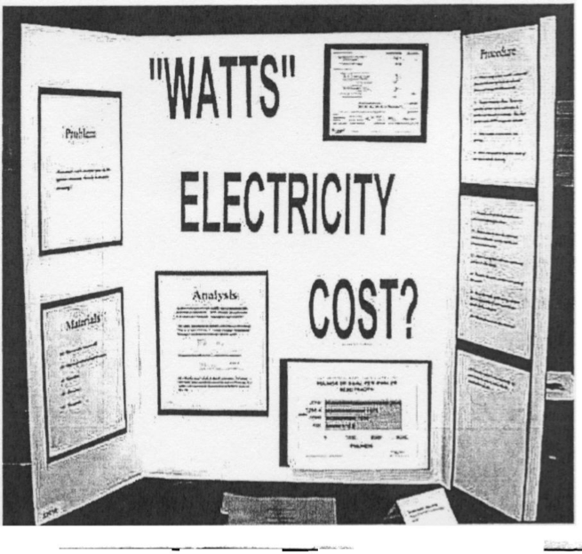

NOTE: The information should be neatly printed on paper. Construction paper may be used as backing for the information. The written research report or abstract will be placed in front of the display.

Projects that do not meet all guideline limitations will not be considered for the awards program.
(Guideline limitations are shown in bold print.)

Revised 11/19/2019

SCORING SHEET
SOCIAL STUDIES
PROJECT NO.
Points Points
Available Awarded

SOCIAL SCIENCE CONCEPTS: 30 ________
Investigates an area of social science
Each aspect of project supports the theme
Research appropriate, consistent and balanced
Analysis is accurate
Age/grade level appropriate
RELEVANCE TO COAL 20 ________
ABSTRACT: 25 ________
Shows depth of understanding
Specific area of social studies is stated; conclusion is reached
Neat, organized and grammatically correct
Appropriate form used
Completion of adequate research
DISPLAY: 25 ________
Relevant to theme
Self-explanatory
Shows creativity and professionalism
Data arranged coherently
Originality of social studies investigation
Within time limit

TOTAL POINTS AWARDED ________

REMARKS:
________________________________________________________________________________________________________________________________________________________________________
____________________________________________________________________________________
Revised 11/12/2018

---------------------------------------------------------------------------------
CEDAR REGIONAL COAL FAIR - AWARDS PROGRAM
---------------------------------------------------------------------------------

- JUDGING WILL BE DIVIDED INTO THREE GRADE LEVELS:
KINDERGARTEN - FOURTH GRADES
FIFTH - EIGHTH GRADES
NINTH - TWELFTH GRADES

- JUDGING WILL BE PERFORMED IN EACH OF THE FOLLOWING SEVEN ENTRY CATEGORIES:
SCIENCE MUSIC
MATH TECHNOLOGY/MULTIMEDIA
ENGLISH/LITERATURE SOCIAL STUDIES
ART

- EACH GRADE LEVEL WILL HAVE A FIRST, SECOND, AND THIRD PLACE WINNER IN EACH OF THE SEVEN CATEGORIES.

- EACH WINNER WILL RECEIVE A CASH AWARD BASED ON THE AVERAGE PERCENT OF TOTAL POINTS EARNED VERSUS TOTAL POINTS POSSIBLE ON THE CURRENT SCORING SYSTEM. AWARDS WILL BE BASED ON THE FOLLOWING:
FIRST PLACE: $1.00 per point
SECOND PLACE: $0.75 per point
THIRD PLACE: $0.50 per point

5. ALL FIRST-PLACE CATEGORY WINNERS IN EACH OF THE THREE GRADE LEVELS WILL BE GROUPED TOGETHER AND JUDGED TO DETERMINE THE OVERALL FIRST, SECOND, AND THIRD PLACE WINNERS FOR EACH OF THE THREE GRADE LEVELS.

6. PRIZES FOR OVERALL GRADE-LEVEL WINNERS WILL BE BASED ON THE AVERAGE PERCENT OF TOTAL POINTS EARNED VERSUS TOTAL POINTS POSSIBLE ON THE CURRENT SCORING SYSTEM:
FIRST PLACE: $3.00 per point
SECOND PLACE: $2.00 per point
THIRD PLACE: $1.00 per point

7. A GRAND PRIZE, AWARDED TO THE STUDENT HAVING THE SINGLE BEST PROJECT IN THE REGIONAL COAL FAIR, WILL BE AN EXPENSE PAID TRIP TO MYRTLE BEACH FOR THE NORTH CAROLINA COAL INSTITUTE'S SUMMER TRADE SEMINAR, WHERE HE/SHE WILL BE PRESENTED A $1,000 CASH AWARD.
GRAND PRIZE TOTAL VALUE: $3,000

IF THE GRAND PRIZE IS AWARDED TO A TEAM, THE TEAM CAPTAIN WILL WIN THE TRIP AND BE RESPONSIBLE FOR TAKING THE WINNING PROJECT TO MYRTLE BEACH FOR DISPLAY AT THE NCCI MEETING.

DISPLAY OF THE PROJECT AND ATTENDANCE AT THE CEDAR AWARDS CEREMONY ARE MANDATORY FOR THE STUDENT TO BE ELIGIBLE FOR THE EXPENSE PORTION OF THE $3,000.

IN THE EVENT THE TEAM CAPTAIN IS UNABLE TO ATTEND, WITH CEDAR’S APPROVAL, ANOTHER TEAM MEMBER WILL BE DESIGNATED TO REPRESENT THE TEAM IN MYRTLE BEACH. THE EXPENSE CHECK WILL BE MADE PAYABLE TO THE STUDENT ATTENDEE AND WILL NOT BE SUBJECT TO DISBURSEMENT AMONG THE OTHER TEAM MEMBERS. THE $1,000 CASH AWARD WILL REMAIN IN THE NAME OF THE TEAM CAPTAIN WHO WILL BE RESPONSIBLE FOR DIVIDING IT WITH THE TEAM.

Revised 11/12/2014

